Big Data Analytics
2. Hadoop HDFS and Map Reduce
2.1 Distributed File Systems: Physical Organization of Compute Nodes, Large-Scale File-System Organization.
2.2 MapReduce: The Map Tasks, Grouping by Key, The Reduce Tasks, Combiners, Details of MapReduce Execution, Coping with Node Failures.
2.3 Algorithms Using MapReduce: Matrix-Vector Multiplication by MapReduce, Relational-Algebra Operations, Computing Selections by MapReduce, Computing Projections by MapReduce, Union, Intersection, and Difference by MapReduce
2.4 Hadoop Limitations.
PAST QUESTIONS:
- List the main components of MapReduce execution pipeline. (D23, M24)
- The Map and Reduce Tasks. (M24)
- Explain HDFS architecture. (M24)
- Write a Map reduce pseudo code to multiply two matrices. Illustrate [10] with an example showing all the steps. (M24)
- Write the limitations of Hadoop. (D24)
- Explain how failures are handled in MapReduce job. (D24)
- Illustrate relational algebra operations with example. (D24)
- Write the functions of the components and execution steps in Map Reduce. (D24, M25)
- What are the advantages and limitations of Hadoop. (M25)
- Explain Selection and Projection algebraic operations using MapReduce. (M25)

NOTES:

*MapReduce tasks :-
At high level, MapReduce breaks input data into fragments and distributes them across different machines.
MapReduce is a programming model used for processing large datasets in a distributed environment with parallel processing.
Map task – A Map task is a single instance of a MapReduce app. The Map task processes input data and converts it into a set of key-value pairs.
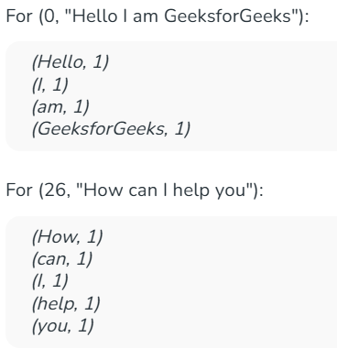
Shuffle or Sort phase – Happens between Map and Reduce. It groups all values with the same key together before passing the mapper to the reduction phase.

Reduce task – A Reduce Task processes an output of a map task. It takes the grouped pairs from the shuffler/sort phase and performs aggregation, summarization and counting. The final set is a reduced set of key, value pairs which is written/stored in HDFS.
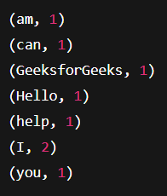

*HDFS architecture :-
HDFS is a distributed file system based on Master–Slave architecture. The Hadoop Distributed File System (HDFS) is a scalable and fault-tolerant storage solution designed for large datasets. It consists of NameNode (manages metadata), DataNodes (store data blocks), and a client interface.
1. NameNode – The NameNode is the master server that manages metadata and controls access to files by clients.
Key Responsibilities:
- Maintaining the filesystem tree and metadata.
- File names, permissions, and hierarchy
- Managing the mapping of file blocks to DataNodes.
- Ensuring data integrity and coordinating replication of data blocks.
Does not store actual data, only metadata.

2. DataNode - DataNodes are the worker (slave) nodes in HDFS, responsible for storing and retrieving actual data blocks as instructed by the NameNode. It periodically sends hearbeats and block reports to the NameNode.
Key Responsibilities:
- Storing data blocks and serving read/write requests from clients.
- Performing block creation, deletion, and replication upon instruction from the NameNode.
- Periodically sending block reports and heartbeats to the NameNode to confirm its status.

3. Secondary NameNode - The Secondary NameNode acts as a helper to the primary NameNode, primarily responsible for merging the EditLogs with the current filesystem image (FsImage) to reduce the potential load on the NameNode. It creates checkpoints of the namespace to ensure that the filesystem metadata is up-to-date and can be recovered in case of a NameNode failure.
Key Responsiblities:
- Merging EditLogs with FsImage to create a new checkpoint.
- Helping to manage the NameNode's namespace metadata.

4. HDFS Client - The HDFS client is the interface through which users and applications interact with the HDFS. It allows for file creation, deletion, reading, and writing operations. The client communicates with the NameNode to determine which DataNodes hold the blocks of a file and interacts directly with the DataNodes for actual data read/write operations.
Key Responsibilities:
- Facilitating interaction between the user/application and HDFS.
- Communicating with the NameNode for metadata and with DataNodes for data access.

*MapReduce execution & components :-
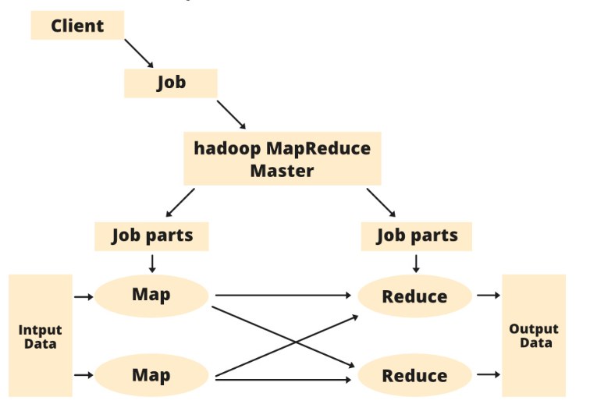
1. Client - The Client is the entry point into MapReduce. It submits the job for execution by packaging the Mapper and Reducer logic into a JAR file and specifying the input and output paths. After submission, the Client’s role ends.
2. Job - A Job represents the complete processing request from the client.
- Internally, it is divided into job parts (tasks).
- Each job part is assigned to either the Map or Reduce phase.
3. Hadoop MapReduce Master - The Master Node coordinates job execution. It:
- Accepts jobs from the Client.
- Splits them into job parts.
- Assigns these parts to the Map and Reduce tasks.
4. Job parts (Tasks) - Every job is divided into smaller units called job parts.
- Map job parts: Process input data splits into intermediate key–value pairs.
- Reduce job parts: Aggregate intermediate results into final outputs.
5. … MapReduce Task Q1 …

Execution Flow of MapReduce Architecture –
- Client submits the job includes JAR file, Mapper & Reducer logic, input path and output path.
- Job Tracker accepts the job, splits it into tasks and assigns them to Task Trackers based on data locality.
- Task Trackers execute Map Tasks on input splits stored locally.
- Intermediate results are shuffled and sorted.
- Reduce Tasks process grouped results and generate the final output.
- Final output is written back to HDFS.

*Relational Algebra operations :-
*Advantages of Hadoop :-
1. Cost Hadoop is open-source and uses cost-effective commodity hardware which provides a cost-efficient model, unlike traditional Relational databases that require expensive hardware and high-end processors to deal with Big Data. Hadoop provides us 2 main benefits with the cost one is it's open-source means free to use and the other is that it uses commodity hardware which is also inexpensive
2. Scalability Hadoop is a highly scalable model. A large amount of data is divided into multiple inexpensive machines in a cluster which is processed parallelly. the number of these machines or nodes can be increased or decreased as per the enterprise's requirements.
3. Flexibility Hadoop is designed in such a way that it can deal with any kind of dataset like structured (MySql Data), Semi-Structured (XML, JSON), Un-structured (Images and Videos) very efficiently. This means it can easily process any kind of data independent of its structure which makes it highly flexible.
4. Speed Hadoop uses a distributed file system to manage its storage i.e. HDFS (Hadoop Distributed File System). In DFS(Distributed File System) a large size file is broken into small size file blocks then distributed among the Nodes available in a Hadoop cluster, as this massive number of file blocks are processed parallelly which makes Hadoop faster, because of which it provides a High-level performance as compared to the traditional DataBase Management Systems.
5. Fault Tolerance Hadoop uses commodity hardware (inexpensive systems) which can be crashed at any moment. In Hadoop data is replicated on various DataNodes in a Hadoop cluster which ensures the availability of data if somehow any of your systems got crashed.
6. Minimum Network Traffic In Hadoop, each task is divided into various small sub-task which is then assigned to each data node available in the Hadoop cluster. Each data node process a small amount of data which leads to low traffic in a Hadoop cluster.

*Limitations of Hadoop :-
- Problem with Small Files -Hadoop is designed to handle a small number of large files by splitting them into blocks (128MB/256MB). When too many small files are stored, the NameNode gets overloaded with metadata, leading to poor performance and making the system difficult to manage.
- Vulnerability – Hadoop is a framework that is written in java, and java is one of the most commonly used programming languages which makes it more insecure as it can be easily exploited by any of the cyber-criminal.
- Low performance in Small Data Surrounding - Hadoop is mainly designed for dealing with large datasets, so it can be efficiently utilized for the organizations that are generating a massive volume of data. It’s efficiency decreases while performing in small data surroundings.
- Lack of Security – Data is everything for an organization, Hadoop uses Kerberos for security features which is not easy to manage. Storage and encryption are missing in Kerberos making Hadoop less secure.
- High Up Processing – Read/Write operation in Hadoop is immoderate since we are dealing with large size data that is in TB or PB. In Hadoop, the data read or write done from the disk which makes it difficult to perform in-memory calculation and lead to processing overhead or High up processing.

